

|  |
| --- |
| 253-555-1111 |
| Smart Phone |
| Dyates7@wgu.edu |
| Envelope |
| Damian J. Yates |
| User |

http://www.damianjyates.com

JoAnn Miller, Supply Chain Department  
Seamus Corporation

650 N South Street  
Dellburg, WI 99999

Dear **JoAnn Miller**,

Damian J. Yates, LLC and its staff would like to thank you for presenting us the opportunity and honor to reply to your request for proposal to upgrade and enhance your existing network infrastructure. Enclosed you will find a comprehensive plan to replace existing hardware with current technologies that will be capable of supporting the changes to your operations and anticipated increase in web visitors and customers to your public facing web servers. Our certified staff only focus will be on this RFP for the entirety of its implementation. We are committed to meeting each objective on time and on budget or better. Upon completion of the project, your staff and customers will observe zero down time or interruptions outside of the planned maintenance windows. Our goal is your complete satisfaction with a hint of astonishment.

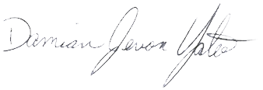Most large companies will split their attention between multiple projects during the same period of time, Damian J. Yates, LLC and its staff devotes the entire staff to one project at a time to ensure no conflict of schedules, readily available resources at all times, and to have the ability to respond quickly to any unforeseen difficulties that may pop up during the project. It is this difference that we try to differentiate ourselves from other providers and hope that you find an added value in the level of service we look forward to providing you and your staff.

Warm regards,

Damian J. Yates

Owner